Project Report Templet

# PLEGGING INTO THE FUTURE : AN EXPLORATION OF ELECTRICITY CONSERPTION OF PATTERNS

1.Indroduction

1.1 overview

# Consumption pattern of energy shows the percentage use of different sources (solar energy, wind energy, geothermal energy, biogas, and tidal power). The consumption pattern of energy changes over time. Commercial sources of energy: Commercial energy makes up about 65% of the total energy consumed in India.

1.2 PURPOSE

**portation, residenconsumption is the actual energy demand made on existing electricity supply for transtial, industrial Electric energy consumption is the form of energy consumption that uses electrical energy. Electric energy, commercial, and other miscellaneous purpose.**

2. PROBLEM DEFENITION & DESIGN THINKING

The environmental problems directly related to energy production and consumption include air pollution, climate change, water pollution, thermal pollution, and solid waste disposal. The emission of air pollutants from fossil fuel combustion is the major cause of urban air pollution.

**1.2EMPATHY MAP**

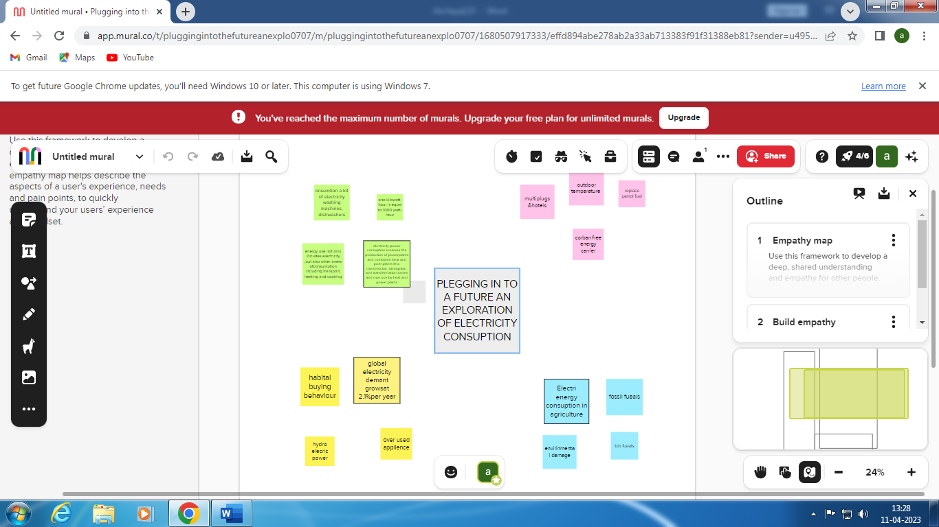

2.2 Problem in electricity consumption

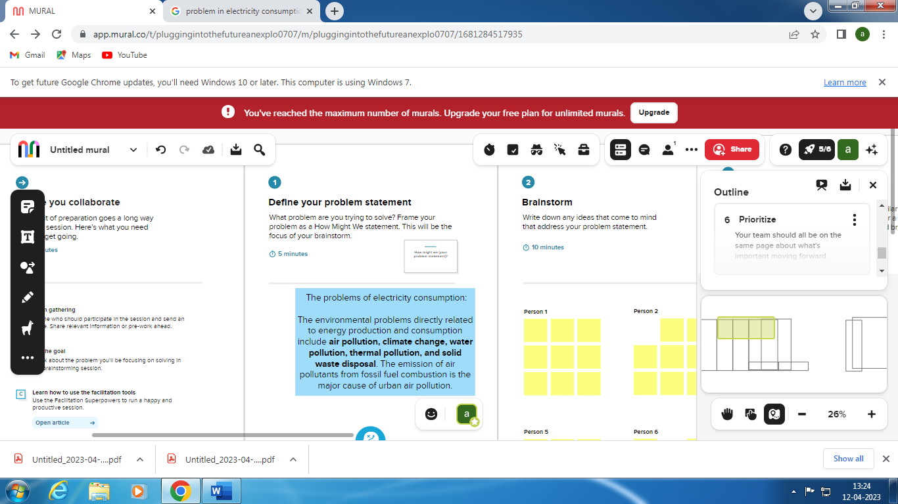

Brainstorm

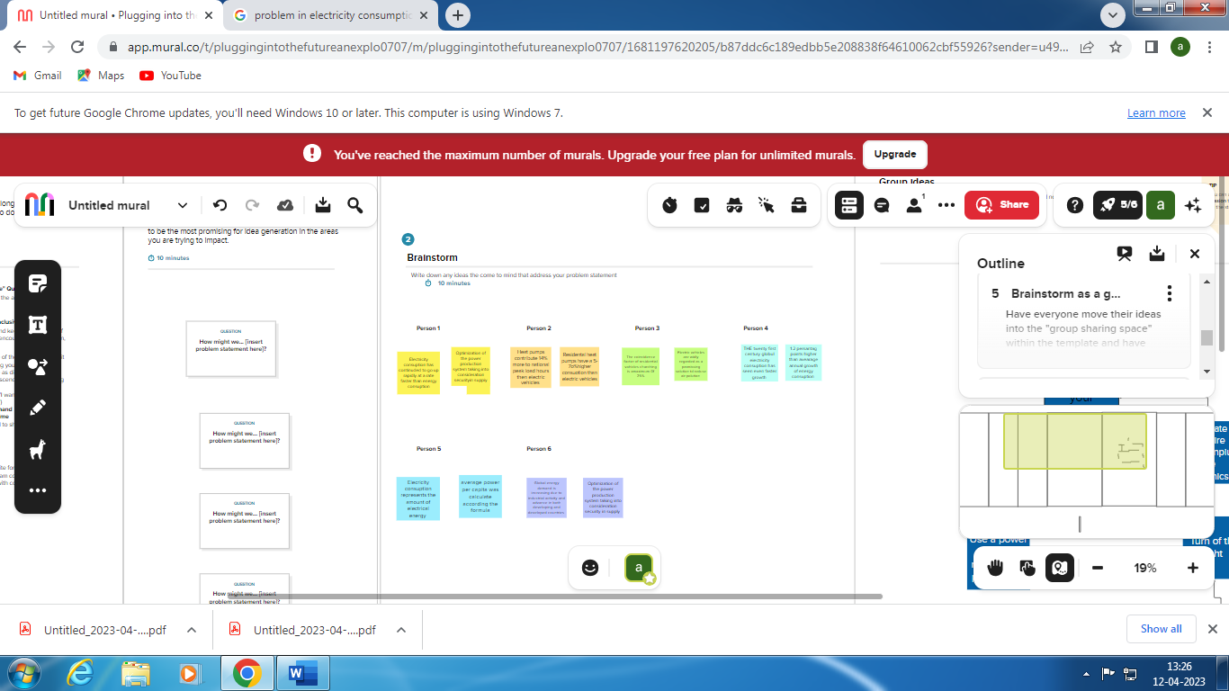

Group Ideas

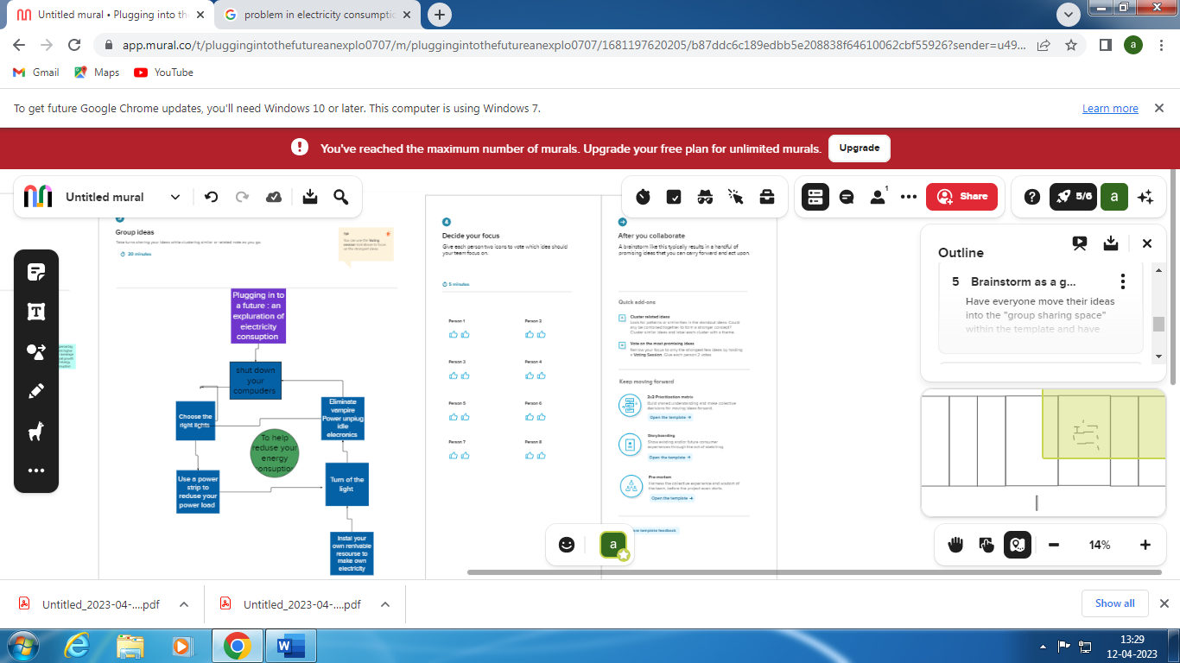

Prioritize

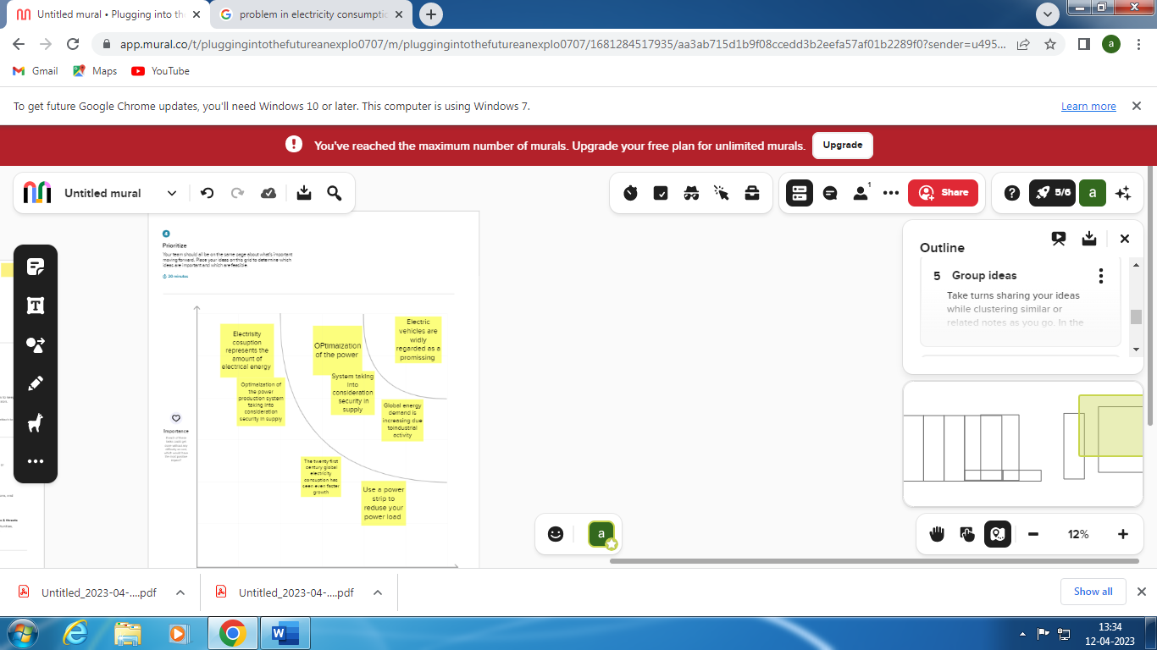

3.Result

Electric energy consumption is energy consumption in the form of electrical energy.[1] About a fifth of global energy is consumed as electricity: for residential, industrial, commercial, transportation and other purposes.[1] Quickly increasing this share by further electrification is extremely important to limit climate change,[2] because most other energy is consumed by burning forReducing energy use in your home saves you money, increases our energy security, and reduces the pollution that is emitted from non-renewable sources of consumption.

Advandages

* The advantage of electric power is its reliable and uninterrupted supply runs the equipment efficiently and continuously. The transportation of electricity is easy once the transmission lines.

*Increased access to electricity **improves education, entertainment, health, comfort, protection, and productivity**.

nctional. They work for years and need no or very less maintenance.

Dis advandages

*The environmental problems directly related to energy production and consumption include **air pollution, climate change, water pollution, thermal pollution, and solid waste disposal**.

* What are the disadvantages of lack of electricity?

**There would be no power to use your fridge or freezer, telephone lines would be down and phone signal lost**. Your mobile phones will be useless as the battery dwindles, with no back up charging option. Your gas central heating won't work and your water supply would soon stop pumping clean water.

applications

**\*EnergySaver** allows users to create profiles for their home and input which devices they use regularly and the utility rates they pay. From there, the app will analyze usage patterns and energy consumption and develop a plan for the user to reduce usage and bills.

*There are many ways you can reduce electricity use in your home: **Appliances and electronics Purchase energy-efficient products and operate them efficiently**. Use an advanced power strip to reduce "vampire loads"--electricity that is wasted when electronics are not in use.

Conclution

Energy efficiency is the wave of the future. ... An energy efficient home is a personal step toward the direction of renewable energy, environmental protection, and sustainable living. Having such a home helps homeowners reduce their bills and provides an excellent investment .Electricity is set to increase further as a result of rising household incomes, with the electrification of transport and heat, and growing demand for digital connected devices and air conditioning.then electricity conception is very usful for future .

Future Scope

* **Rising prosperity and expanding commercial activity** leads to a more than 15% increase in energy demand. Strong middle-class growth in developing nations increases energy demand by about 35%.Improving building efficiencies reduce energy demand in developed countries by about 15% by 2050.

* As the Indian government plans to increase electrification of rail-route kilometers from 40 percent presently to 77 percent by 2022, the level of electricity consumption achieved by 2030 could be 35-43 TWh, growing at 5.0-6.3 percent CAGR from 17 TWh in 2015

. *In the Stated Policies Scenario, **global electricity demand grows at 2.1% per year to 2040**, twice the rate of primary energy demand. This raises electricity's share in total final energy consumption from 19% in 2018 to 24% in 2040. Electricity demand growth is set to be particularly strong in developing economies.

Appendix